GREAT LAKES TALKING BOOKS NEWSLETTER

Spring/Summer 2019

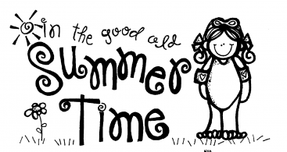

Great Lakes Talking Books (GLTB)

Reader Advisory and Outreach Center

1615 Presque Isle Ave., Marquette, MI 49855

1-800-562-8985 (Michigan) Ext. 0 or 1-906-228-7697, Ext. 0

Website: http://joomla.uproc.lib.mi.us/gltb1/

Email: tb@greatlakestalkingbooks.org

Facebook: https://www.facebook.com/gltbuppermichigan

Dear GLTB Patrons;
We made it! That was quite a winter! Isn’t it great that we had good books to enjoy listening to while the snow piled up outside? Spring and summer is welcomed with open arms!
Hopefully, you’ve been receiving the type of books you like. If not, please give us a call or email, and we can make changes to your Profile Authors or Profile Subjects lists.
Attached to this newsletter is a patron survey. We would really appreciate it if you could fill it out and mail it back to us. Your responses make the Talking Book Program even better. If you would like to respond to the questions over the phone, give us a call and we can fill it out at our end. You do not need to give us your name. If, however, you would like adjustments made in the type of book you’re receiving or other changes, we will need your name.
Happy Reading!
Lynn Buckland-Brown,
Reader Advisor

WELCOME TO OUR STAFF, JEREMY AND TONIA!
Jeremy Morelock and Tonia Bickford are now working part time as Reader Advisors for Great Lakes Talking Books in Marquette. You may have met Jeremy when he worked at Peter White Public Library in Marquette. He is happy to help with any problems or requests you may have. Jeremy will be answering phone calls on Monday mornings, Wednesdays, Fridays, and any time Lynn is busy or not available.
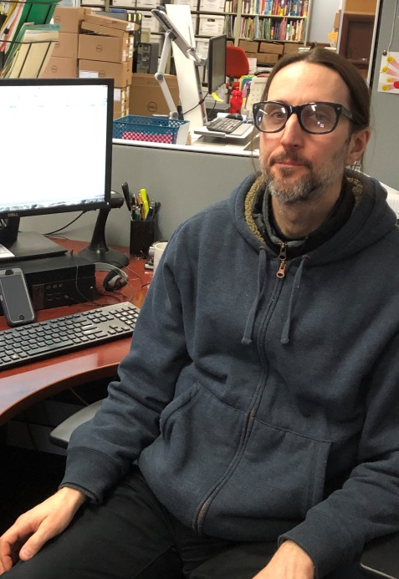
Jeremy
Tonia will be filling in as a Reader Advisor when Lynn is out of town. She worked with the Talking Book Program at the Ann Arbor District Library so is very knowledgeable about the program. She also works at the circulation desk at Peter White Library.
Access to Magazines and Newspapers
Active patrons now have access to at least 60 magazines that are available through the National Library Service. A list of available titles can be found under Audio Magazines in all editions of the Talking Books Topics catalog. It takes at least eight weeks for a subscription to get started. It takes about two months to record Michigan History Magazine, which is why they will arrive about two months after their month of publication. Two other services also provide magazines and

newspapers to individuals enrolled in our service. The National Federation of the Blind sponsors NFB-Newsline, which provides access to more than 400 newspapers and magazines. For information, visit www.nfbnewsline.org or call NFB at 866-504-7300. Additionally, Choice Magazine Listening (CML) is a free audio magazine for adults with impaired vision or other disabilities. Four times a year, listeners can download or receive by mail 12 hours of great stories and articles chosen from 100 of the finest magazines free of charge. For information, call 888-724-6423 or contact
www.choicemagazinelistening.org.

Please Return Your Books as You Finish Them

After you’ve mailed it, a book may take a week to reach the Circulation Department in Lansing. Once it is received, it may take up to three days for the next book to go in the mail to you. Then, that book may take a week to be delivered to your home. If you put all of your books in the mail at one time, you could be waiting quite a while before the next group of books is finally delivered to you! By putting your books in the mail as you finish them, one at a time, you will hopefully have books to read while waiting for the replacement to arrive. We can always increase the maximum number of books you receive at any time. Just call!

Overdue Magazine Cartridges

Magazine cartridges for the digital player come in red containers and have light blue cartridges. If you’ve ordered magazines, please listen to them right away and send them back by flipping the address card over. The audio Talking Books Topics on a cartridge, that some of you receive, does not need to be returned in the cardboard mailing box that it came in. The return address label is already affixed to the container. Simply put the cartridge back into the container and drop it in the mail- no card needed.

Computers for the Blind Facts
Computers for the Blind is a non-profit 501 (c)(3) organization located in Richardson, TX. They provide refurbished computers with assistive technology to persons who are blind or have low vision. Shipping is Free in the USA. There are no income or age requirements.
Processing Free
- Desktop system -$130
- Laptop -$185
- Ask about grants that lower the cost of computers, and how to save $20 by excluding the monitor for a desktop.
There are upgrades to systems available as well as various options which cost extra. If you would like an information sheet about this program sent to you, call us at Great Lakes Talking Books (800-562-8985, Ext. 0).
To order a computer or if you have questions call
214-340-6328
Or go to: www.computersfortheblind.org

Bookshelf Feature on Digital Players

When a book cartridge has several books or magazines on it, the user can jump from book to book or magazine to magazine by using the bookshelf feature.
- Hold down the green PLAY/STOP button for a few seconds. The machine will announce “Bookshelf”.
- The REWIND or FAST FORWARD keys can then be used to move backwards and forwards from book to book and magazine to magazine. Don’t hold the button down, just tap it.
- When you hear the book title you want to listen to, tap the PLAY/STOP and begin listening to it.

NEVER PAY POSTAGE TO SEND ANYTHING BACK!!

FREE MATTER FOR THE BLIND applies to just about anything you are sending to the library, including books, order forms and machines. Write FREE MATTER FOR THE BLIND on the box or call and ask for a label. The only materials that patrons CANNOT send Free Matter for the Blind are hand-written letters. You’ll have to put a stamp on them.

Machine says “End of Book”, but it’s not?

It’s very frustrating when you put a new book in the player, press Play/Stop and you hear “End of Book”. This means that the book has become corrupted. You can’t fix it. Call your Reader Advisor to request another copy and return the defective one. However, in order to notify us that the cartridge is defective, write a note and put it in the case with the cartridge or put a large X on the card. Working together, we can rid our collection of corrupted files, meaning fewer disappointing cases of the dreaded “End of Book”!

Need Help?
If you ever feel like you are not receiving enough books, there are several reasons this might happen:
- You have caught up with all of the books written by your favorite authors.
- You are set up as “request only” but have not given us new titles to add to your account.
- You are at your book limit and need to return some items.
- You may need to increase the maximum number of books you receive.
- Your desired preferences are too limiting. For example, you would like mysteries but have “no violence” in your preferences.
- You have moved but haven’t notified us of your new address.
- You have not requested or received a book within the past year.
- There are problems with your mail delivery system- too small of a box at the post office?

Thank Your Postal Carrier
For many patrons who receive their books in the mail, the arrival of their postal carrier with that little cartridge is much anticipated and appreciated. If you would like to thank your postal carrier directly, we have drafted a letter for you to use. It’s on the top of the next page. Just cut it out, sign your name and leave it for your postal carrier, as an expression of your appreciation for all they do to bring you those containers filled with knowledge, romance, adventure, and more.

To My Mail Carrier;
Thank you so much for being part of my Braille and Talking Book service. Each time you deliver a plastic box with an audio book or magazine, or a Braille book, I travel to different places, experience exciting adventures and learn about new topics.
Without your assistance, I could not continue to experience the joy of reading!
Your Friend;
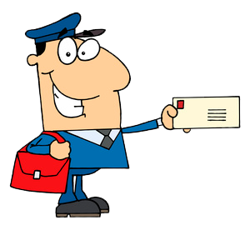 THANK YOU!!!!!!

Great Lakes Talking Books FREE MATTER
1615 Presque Isle Avenue FOR BLIND
Marquette, MI 49855 OR HANDICAPPED

