How to Discard Items

(This is a companion to the podcast at http://www.uproc.lib.mi.us/podcasts/DiscardLostAndMisingProcedures)

There are three different ways to remove items from the system. The safest way is to charge items out to a discard user. This also allows one to keep statistics on how many items are discarded. Another way is to use the global modification wizard to change the home location to DISCARD. This does not allow for statistics to be kept. The unsafe way is to use the Delete Title, Call Numbers or Items wizard. Please do not do this, as it can break links to bill, holds and other databases. Those broken links can cause a lot of different problems.

If you have a discard user, simply bring up that user record and scan the items to be discarded. You may also type in barcodes. If you do not have a discard user (each library has their own), you can e-mail support@uproc.lib.mi.us to have one created for you.

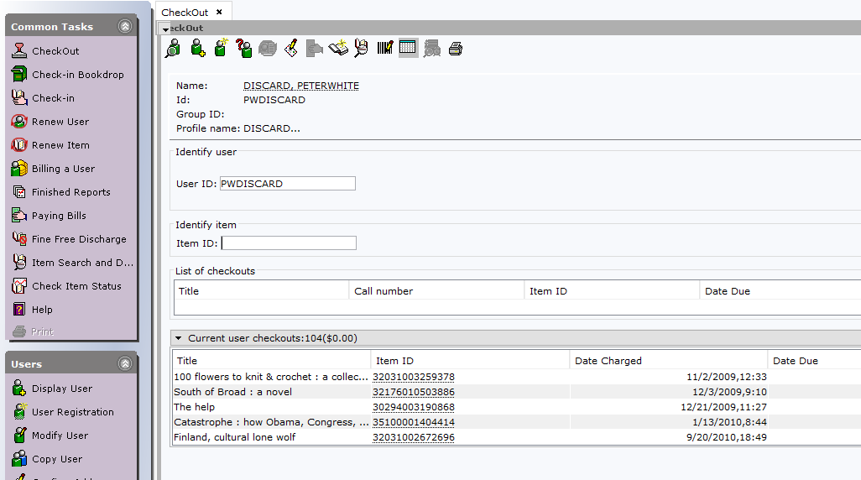

This also gives you a nice display of what items have not yet been removed from the system. If you charge an item to the discard user by accident, simply check in the item, and it will be returned to normal.

Items will be visible in Workflows until removed from the system, but will not be visible in the OPAC. This allows bills to be paid or forgiven but means that the item cannot be seen by patrons and cannot be chosen to fill a hold. We run reports weekly to remove items with no bills, serial controls or holds from the system permanently.

Once the item is charged out to the discard user you may dispose of it as you usually would.

If you prefer to use the Global Item Modification wizard, it is under the Item group of the Cataloging tab.

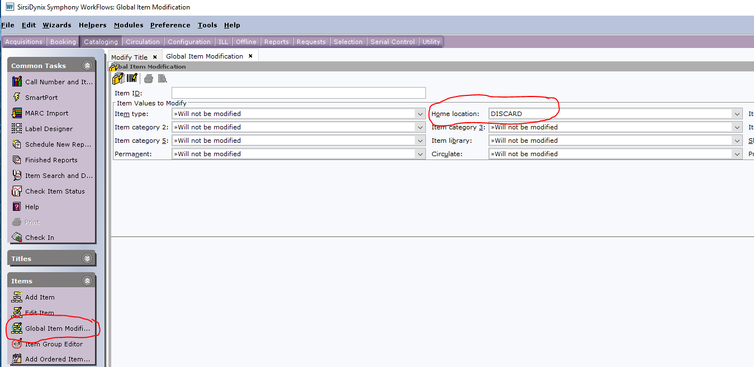

Change the home location to DISCARD, and scan or type in your item IDs. This will shadow items, making them invisible in the online catalog. Items will still be visible in Workflows, but will not trap holds. Once all serial controls, holds and bills are cleared from the item, the weekly discard reports will permanently remove items from the catalog.

If you accidentally scan an item, manually change the home location back to what it should be.

Once you scan an item and assign its home location to DISCARD, you can treat the item as if it has been removed from the system.

Unnecessary Details for Those Who Want Them

Discard users are one of a group of special users (others are MISSING and REPAIR) that have special user profiles that cause specific things to happen. Discard users have a user profile of DISCARD.

When an item is charged out to the discard user, it changes the current location of the item to DISCARD. The DISCARD location is shadowed, that is, items in that location can be seen and modified in Workflows, but patrons cannot see them in the OPAC and they cannot be used to fill new holds. Items with copy level holds will not be removed. Nor will items under serial control.

Once a week, we run the Remove Discards report. It deletes all items in the system that have no bills or holds attached. Items that are not removed will remain in the DISCARD current location until they have no bills.

You can leave items charged out to the discard user until they are removed. You may choose to remove small fines and bills or all fines and bills that are old. Contact support@uproc.lib.mi.us if you wish this done in bulk.

