Lost Items

(This is a companion to the podcast at http://www.uproc.lib.mi.us/podcasts/DiscardLostAndMisingProcedures)

There are two kinds of lost items. LOST-CLAIM items have been manually marked lost in the Mark Item Lost wizard. LOST-ASSUM items have been overdue for so long that the system assumes they are lost.

As with DISCARD and MISSING, the two lost locations are special locations. Items with either of the lost locations are shadowed, that is, they are visible to staff in Workflows but are not visible in the OPAC. Items with either of the lost locations cannot trap holds. If the item has a location of LOST-CLAIM or LOST-ASSUM, a bill has been generated for the patron who had the item charged out. (If a patron does not have the item charged out, the procedures for MISSING items should be used instead.)

There are two ways to mark an item LOST-CLAIM. The easier way is to open the patron record in the Display User wizard, then right click on the barcode (Item ID) of the lost item. You can then click on Mark Item Lost.

(Please do not mark items missing here. Missing status is for books we can’t find in our libraries. If the patron can’t find it, it is lost, not missing.)

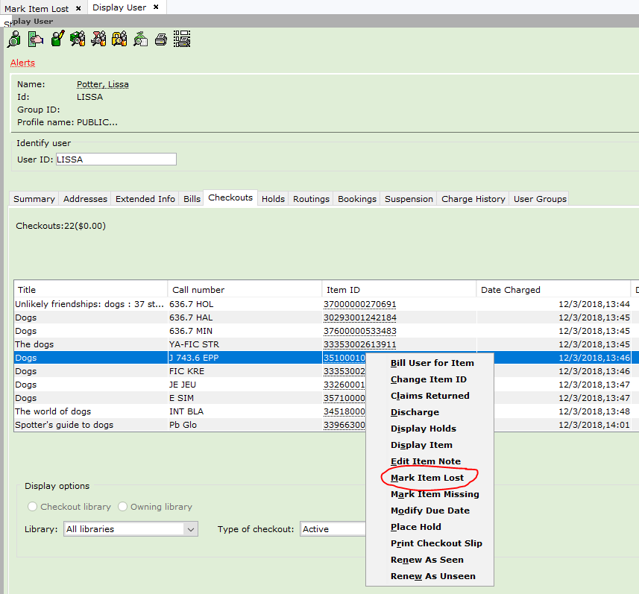

You will be prompted if you really wish to mark that item as lost.

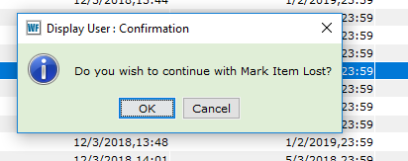

If you do, click on OK. If you don’t, click on Cancel.

This will bring up the billing box, where you may modify the bill if needed.

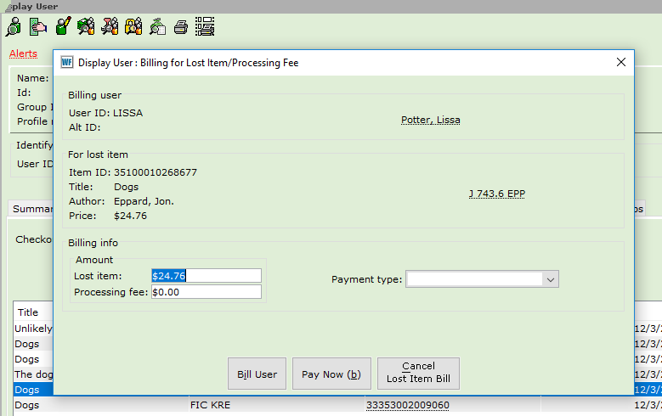

Please do not use the Cancel Lost Item Bill button. It cancels the bill completely and does other unexpected things. If you made a mistake, it is better to use Pay Now and forgive for the payment type.

If the patron is going to pay for the item right now, select a payment type, then click on the Pay Now button. To create a bill to be paid later, click on Bill User. You will get a confirmation message.

You can also mark an item lost using the Mark Item Lost wizard. Go to the Circulation tab and open the Mark Item Lost wizard.

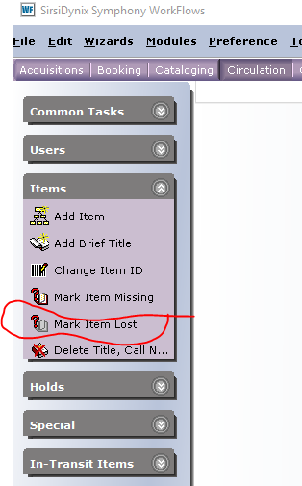

This will bring up the Mark Item Lost wizard.

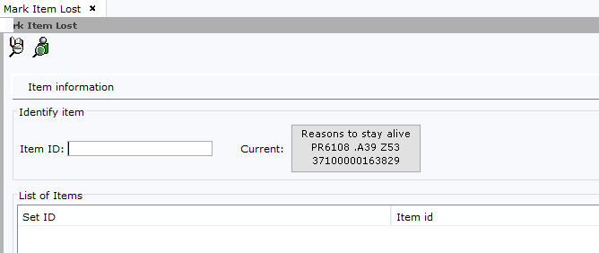

You can use either the Item Search helper or the User Checkouts helper to bring up the item that needs to be marked as LOST-CLAIM. Most of the time, you will probably use the User Checkouts helper. If you use the Item Search helper, it is helpful to make sure you are limiting the search to your library.
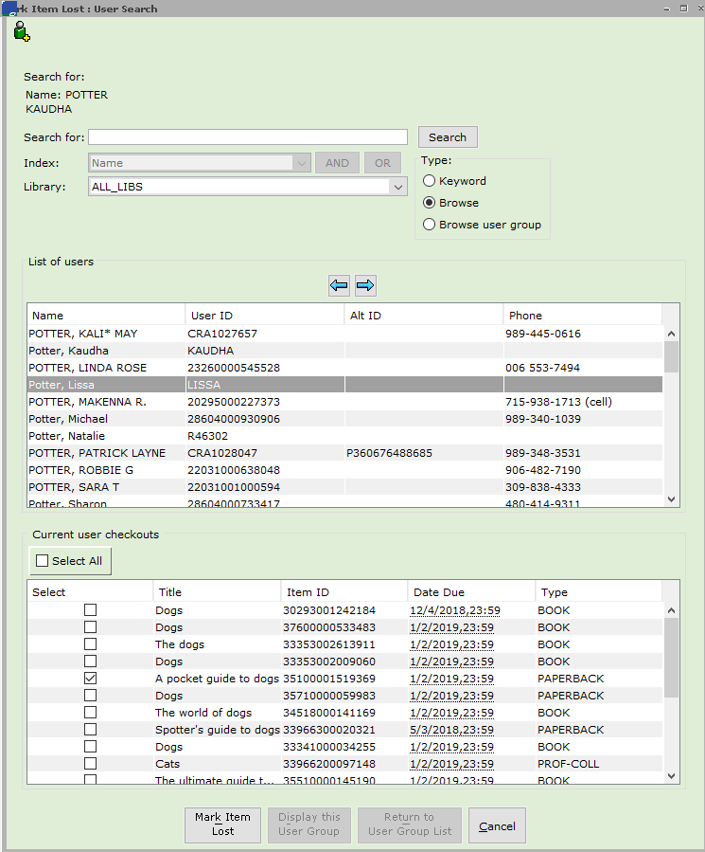

After selecting the correct item or items, click on Mark Item Lost. This will populate the Mark Item Lost wizard with the correct Item ID.

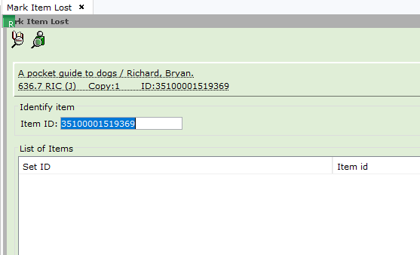

You will need to click on Mark Item Lost again to bring up the billing screen.

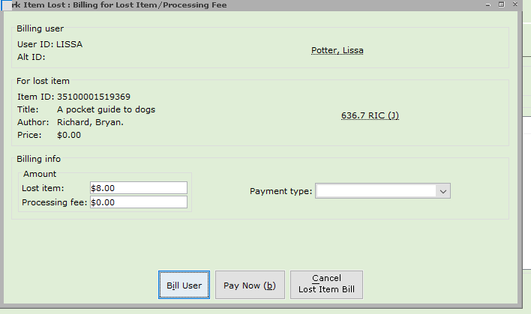

If the catalog record has a price, that will populate the Lost Item amount field. If it doesn’t, the default price will populate that field. You can change this amount. You can also add or change the Processing fee. Then select the Payment type, if the patron is paying, and click on Bill User or Pay Now.

A bill will be generated (either paid or unpaid) on the patron record. The item will be given a current location of LOST-CLAIM.

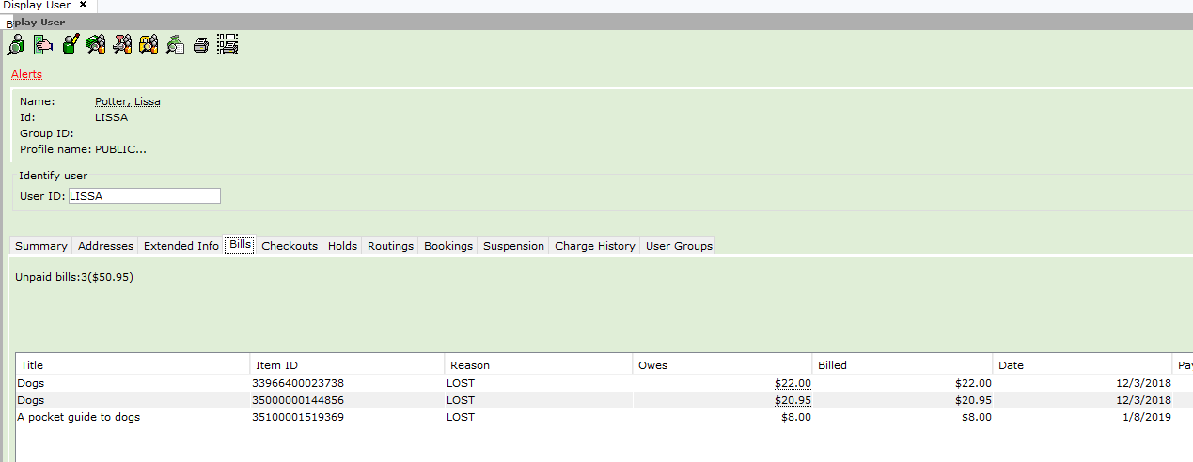

The third item is the item that was assigned to the special location LOST-CLAIM using the Mark Item Lost wizard. The first two items have been assigned to the special location LOST-ASSUM by the system, since they are very overdue. The bill reason is LOST.

Remember, you will be clicking on Mark Item Lost twice. If you do not get to the billing screen, the item has not been marked lost.

Please always use the Mark Item Lost wizard or use the right click on the patron record to change items to lost. Do not change an item manually to have a current or home location of LOST. If you do so, bills will not be not generated properly and Strange Things will happen.

Please do not use the Bill a User wizard to create a LOST bill. It does not do the special processing needed. It will create a bill, but that bill will not be correctly linked to the item. The item will not be shadowed and can trap holds. This is a particular problem when a patron finds the item and wishes to get a refund.

We run reports to permanently remove LOST items when they no longer have bills, holds or serial controls attached to them.

