Missing Items

(This is a companion to the podcast at http://www.uproc.lib.mi.us/podcasts/DiscardLostAndMisingProcedures)

MISSING, like LOST and DISCARD, is a special system location indicating a particular status. The MISSING location is used for items that can’t be found and are not charged out to a patron. Missing items must be set to MISSING using the Mark Item Missing wizard in the Circulation toolbar.

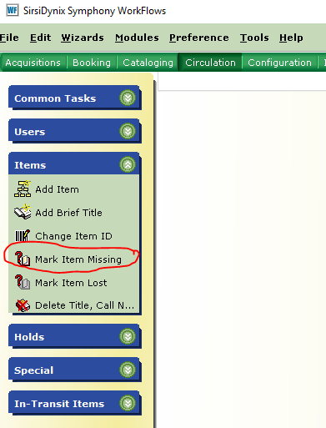

Opening the Mark Item Missing wizard will bring up an Item Search box.

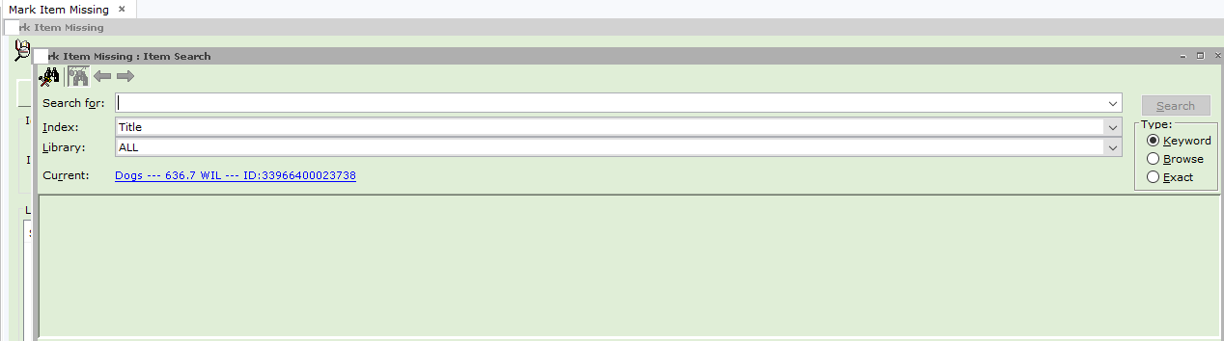

If you wish to use a prompted Boolean search, you can click on the binocular helper. If your search box is not limited to your library only, it would be very useful to change it to just your library.

Search for the missing item.

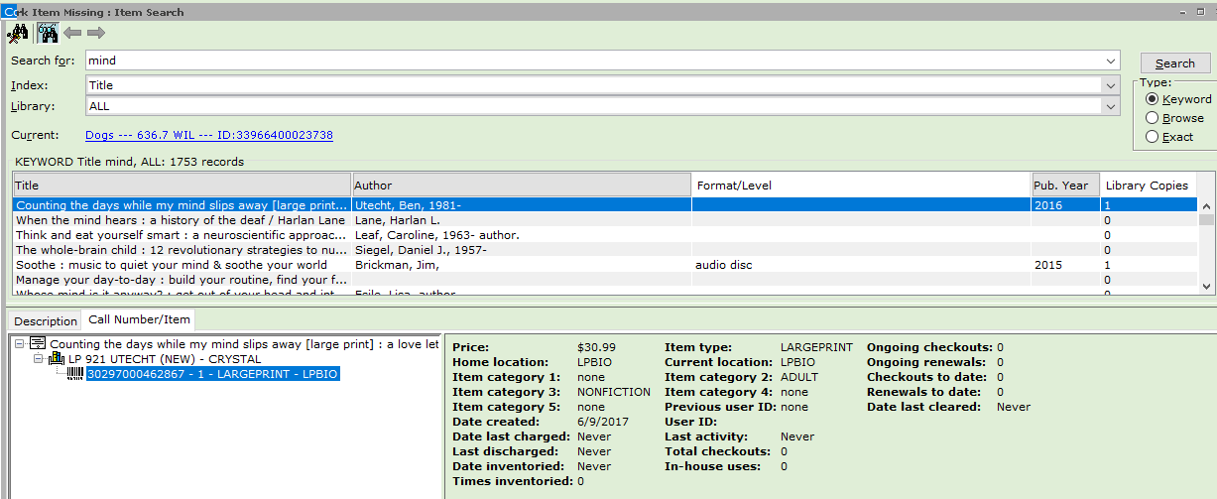

Select the correct item, and click on Mark Item Missing. This will populate the Mark Item Missing wizard with the correct Item ID.

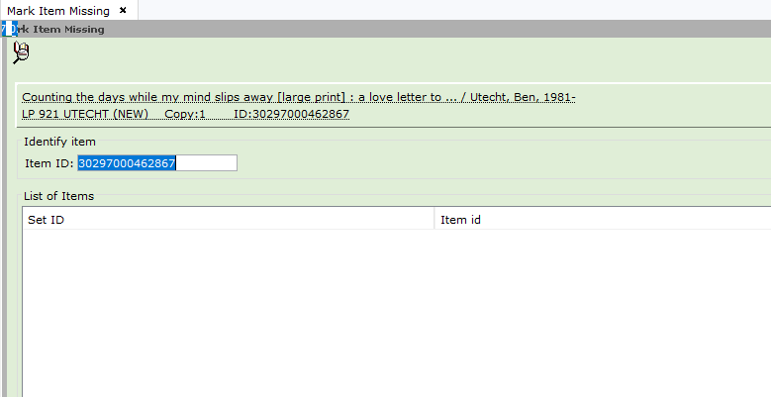

You will need to click again on Mark Item Missing to set the item to MISSING.

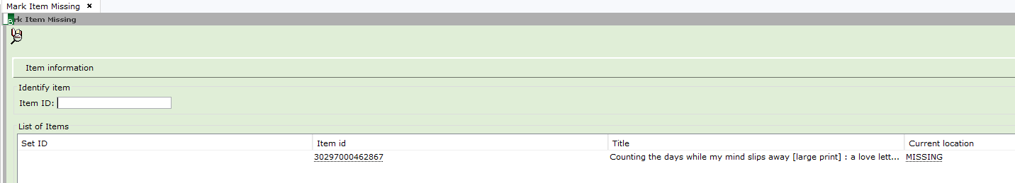

Remember, you have to click on Mark Item Missing twice to change the current location (status) to missing. If you do not get to the screen above, which shows the item is in a current location of MISSING, the item was not successfully marked missing.

You can also mark items missing from the Onshelf Items wizard.

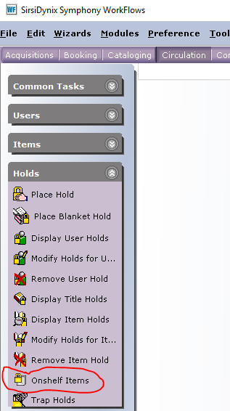

Select the item you cannot find, and right click.

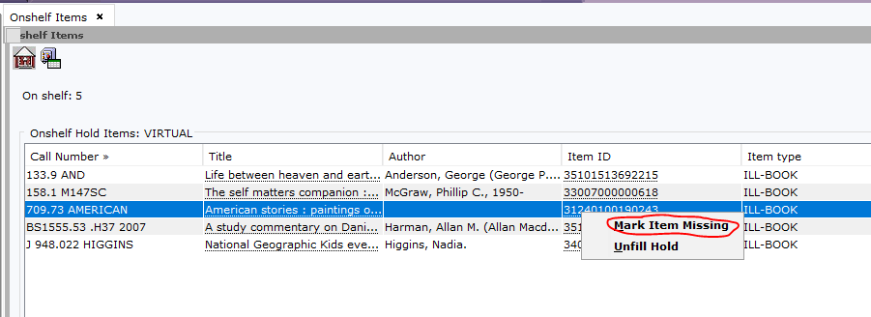

Highlight Mark Item Missing, and click.

We can run reports to convert MISSING items to DISCARD items, or to list MISSING items so they may be searched for on the shelf.

Items with a current location of MISSING will not trap holds. Nor will they be visible to patrons in the OPAC. Staff can see missing items in Workflows.

Should you find an item that has been marked missing, you can clear it in Check Item Status.

