Workflows Searching

(This is a companion to the podcast at; http://joomla.uproc.lib.mi.us/slc/)

You can change defaults in the search behavior of any wizard that searches either by right clicking on the wizard in the left column or setting the properties to come up every time you open a wizard. The screen that opens looks like this;

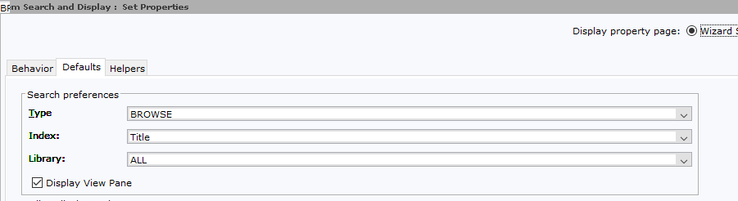

Type and Index are a bit confusing. They also tend to change oddly after failed searches. Type is keyword, browse or exact.

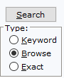

Keyword is a google-type search. Browse is a right truncated search that puts you where you can move forwards and backwards in a list of hits. Exact is very exact – if you do an exact search on a title that has a subtitle, you must have the full subtitle in the search bar, or the title will not retrieve. This search is not right truncated.

Index is which index you wish to search in. For the most part, these are obvious – the author index covers authors, the subject index covers subjects, etc. There are a couple that are tricky. The General index covers everything that is indexed, including ISBNs and ISSNs. Series will only bring up titles that are cataloged as series. Title control # index is, in general, not something that you will need to use.

Depending on the index, different types of search are the default. This can be very confusing, as, after a failed search, Workflows will sometimes switch the index and/or the search type to something unanticipated. If your search isn’t working the way you think it should, the first thing to check is the index and the search type.

Getting Help and Specialized Searching

The help file for searching in Workflows is quite good, and covers a lot of searching methods that aren’t needed every day, but that can make life much easier with difficult titles. To find it, drop down the Help menu in Workflows, and pick Contents.

This will flip you to a web browser.

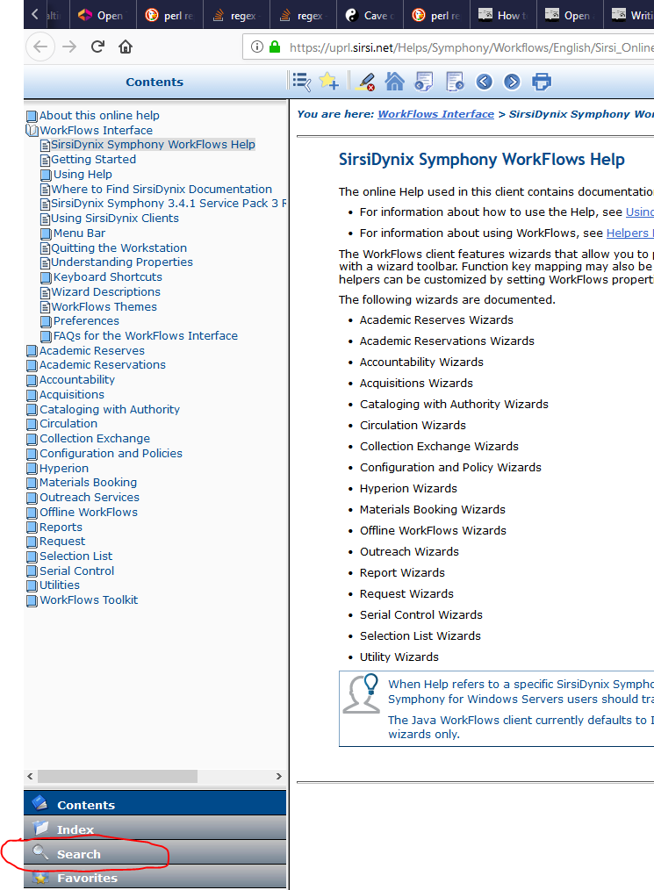
Click on Search. Type in “search” in the search box.

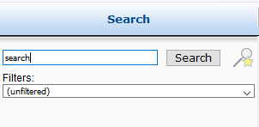

This will bring up a bunch of articles, but the one we want is Search Strategies and Browsing Techniques.

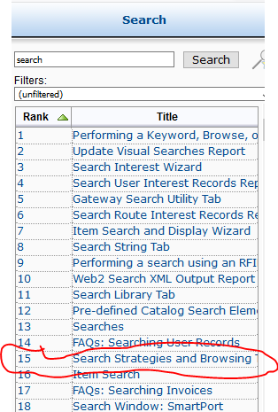

Double click on it.

Complex Search Overview

There is a lot of information in the Search Strategies and Browsing Techniques help article. It includes Boolean, positional and relational operators, the use of single quotes for exact phrase searching, keyword index synonyms, MARC tag searching (curly bracket searches), stopwords, variables, special characters and more.

These search methods work in Workflows, but not in Enterprise (the OPAC).

Boolean operators, that is AND, NOT, OR and XOR, work as expected. As we shall see in the example section, this leads to titles containing any of those words not coming up as one might expect, since Workflows reads those titles as containing a Boolean search, not as a regular search. You can get around this by enclosing the title in single or double quotes. This effectively turns off Boolean (and positional) operators.

Positional operators, SAME, WITH, NEAR and ADJ, work as expected. As with the Boolean operators, this can lead to confusion when searching for titles containing those words. Enclosing your search term in single or double quotes will tell Workflows to search on the entire phrase without using positional operators.

Relational operators are used mainly for dates, although you can use them for call numbers. They are <, >, =, < >, <= and >=. If you are searching publication year, be aware that Sirsi indexes the year the title was entered in to Workflows as the pub year, *not* the year the title was published.

Curly bracket searching, or, as Sirsi calls it, searching specified entries, is very useful. This allows you to construct complex searches based on MARC tag numbers or on keyword index synonyms. This makes it easy to search for titles by Mark Twain or titles about Mark Twain. It allows combining different indexes, say a title and an author. See the examples section for how this can be used.

Stopwords are common words that are not indexed, and, therefore, cannot be searched on. Enclose your search in single or double quotes to get around this.

Variables can be used for substitution and truncation. Browse searches are right truncated by default, so you only need to type in as much of the author, title (or patron name) as you need to get a unique result. ? fills in for any single character. $ is a truncation operator.

The way Workflows transliterates special characters is pretty odd. Should you need to search a title with a Polish L or a thorn, for example, you will need the table in this help file.

Punctuation is generally ignored, unless you enclose the phrase in single or double quotation marks. There are some punctuation characters that are replaced by spaces.

Examples

Not Without My Daughter, Bud, not Buddy and Not Without My Sister cannot be found unless enclosed in quotation marks. This is because “not” is a Boolean operator.

You Bring the Distant Near will fail on a title keyword search. “Near” is a positional operator. If you enclose the title in quotation marks, it will come up.

Same Beach, Next Year will fail on a title keyword search. “Same” is a positional operator. Enclosing the title in quotation marks will retrieve the title.

With or Without You will also fail on a title keyword search. “With” is a positional operator. Putting the title in quotation marks will allow retrieval.

Near and Far will also throw an error on a title keyword search. “With” is a positional operator and “and” is a Boolean operator. “near and far” will retrieve the title.

Single word titles tend to be very common. Rather than scrolling through a long list of titles looking for the correct author, curly bracket searching can be used.

Fire, by Sebastian Junger
Use the general index, keyword type, then search for fire {ti} and junger {au}.

Magic, by Tami Hoag
Use the general index, keyword type, then search for magic {245} and hoag {100}.

Magic, by Tami Hoag, large print only
Use the general index, keyword type, then search for magic {245} and hoag {au} and “large print” {ti}.

Love, by Toni Morrison
Use the general index, keyword type, then search for love {ti} and Morrison {100}.

It, by Stephen King
Use the general index, keyword type, then search for “it” {ti} and king {100}. It must be in quotation marks because it is a stopword.

Stopwords occasionally cause problems in searches. There is a pop group named “The The.” We don’t have any of their CDs in our system, but if we did, the only way to find the group would be to use quotation marks.

To find books about Mark Twain rather than by him, you can either do a subject index search or use the general index, keyword type and search on mark twain {su}.

Keyword Index Synonyms

Author index, au is the synonym, MARC tags included; 100, 110, 111, 700, 710, 711
Title index, ti is the synonym, MARC tags included; 130, 245, 440, 730, 740
Subject index, su is the synonym, MARC tags included; 660, 610, 611, 650, 651, 690, 691
Series index, ser is the synonym, MARC tags included; 400, 410, 411, 440, 800, 810, 811, 830, 840

