Options for Titles Not Found in Smartport

When a title cannot be found in our catalog or in Smartport, there are two options. The first is to send scans of the cover (including the back cover if there is useful information there) and verso to support@uproc.lib.mi.us with a request to create a catalog record. The second option is to create a brief record with a local note that alerts Superiorland staff to finish the record.

If you choose to create a brief record, the record needs to have enough information to identify the title. At a minimum, it needs;

- ISBN (020) and/or LCCN (010)
- Author (100)
- Title (245)
- Publisher and publication date (264)
- Pages and/or length (300)
- Format (336, 337 and 338)
- 590 tag with “upgrade”

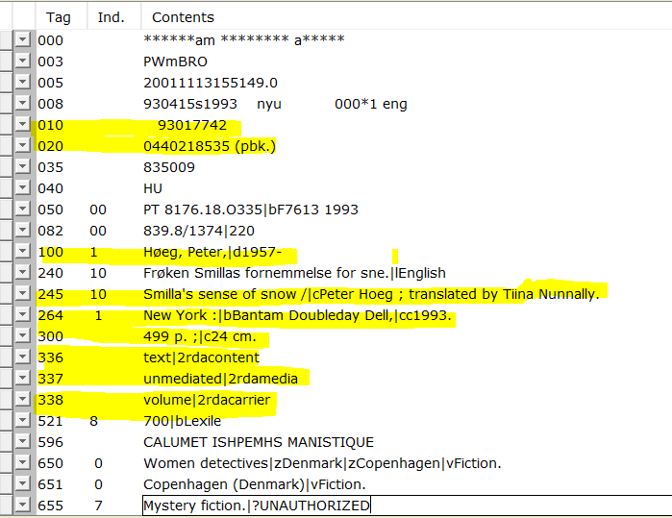

This is an acceptable brief record;

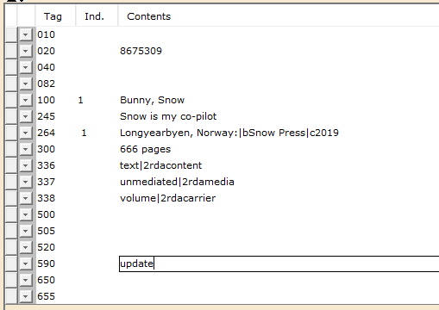

There is enough information to be able to look up the title and to display properly in Enterprise. The 590 tag is there, which will be picked up in a report to notify co-op staff to complete the record.

This record does not have any 6xx tags, any content information or any of the other information that enhances searching. We run a monthly report to pull all records with “update” (lower case, no quotation marks) in the 590. We can then expand those records. But, in the meantime, the title is in the catalog and somewhat findable.

LCCN numbers are a bit tricky. Please see the LCCN Formats for Cataloging document for information on how to enter them in to Workflows.

